------------------------ START TRANSMISSION ------------------------
YOUR FORCE IS ORDERED TO THE RENORSAL SYSTEM TO RECOVER STAR LEAGUE DEFENSE FORCE EQUIPMENT. RENORSAL WAS PART OF THE TRADERS DOMAIN 2730 LAND RUSH FOR RARE METALS. THE SLDF SENT THE 61ST ROYAL JUMP INFANTRY DIVISION TO GARRISON TRADERS DOMAIN TO MONITOR THE RESOURCES. 61 RJID WAS DEPLOYED TO SUPPORT THE SLDF RESPONSE TO THE AMARIS CIVIL WAR. FOLLOWING THE AMARIS CIVIL WAR THE 61 RJID LEFT THE INNER SPHERE AS PART OF OPERATION EXODIUS. LOCAL SCAVENGERS REPORTEDLY ARE WILLING TO SELL INFORMATION ON THE LOCATION OF 61 RIJD HIDDEN SUPPLY CACHES. YOUR FORCE IS ORDERED TO RECOVER AS MUCH SLDF EQUIPMENT AS POSSIBLE.
------------------------- END TRANSMISSION -------------------------

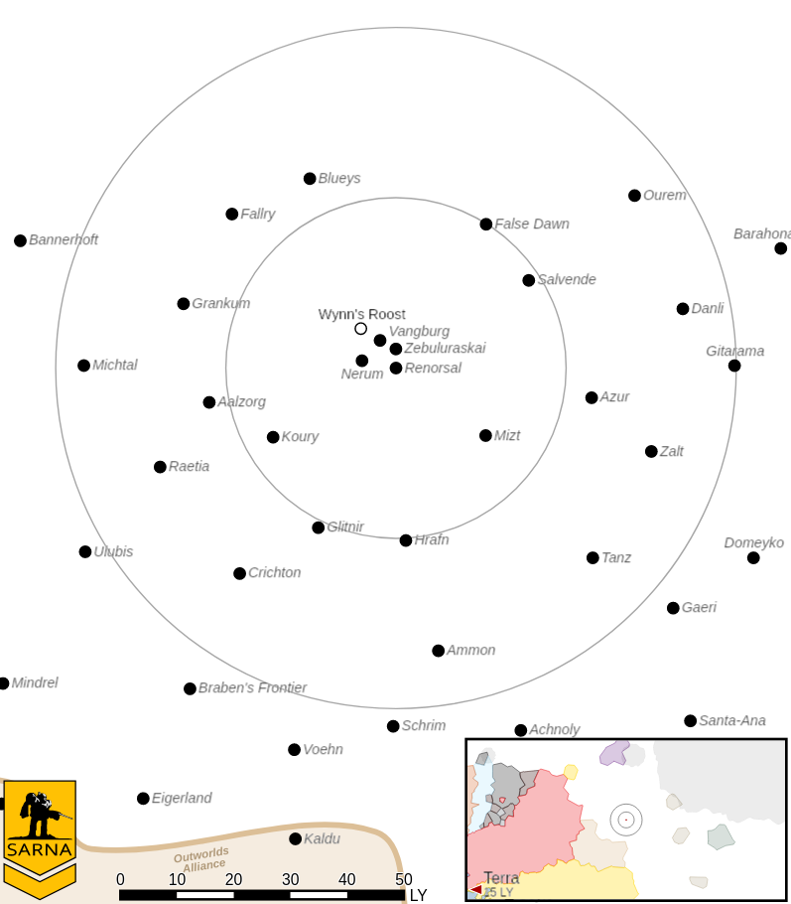
------------------------ START TRANSMISSION ------------------------
THE LEADER OF A GROUP OF LOCAL SCAVENGERS ON RENORSAL III IS WILLING TO EXCHANGE INFORMATION ON THE LOCATION OF 61 RJID SUPPLY CACHES FOR EMPLOYMENT AND TRANSPORTATION OFF WORLD. EXTRACTION WILL BE IN THE EQUATORIAL FORESTS. THE FINAL LOCATION WILL BE CONFIRMED BY RADIO TRANSMISSION WHEN YOUR FORCE REACHES THE AREA.
------------------------- END TRANSMISSION -------------------------

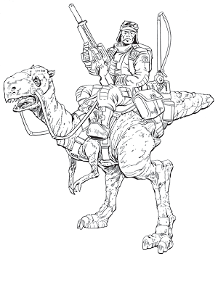

The attacker's primary objective is to extract the scavenger leader by having a unit carry them to the attacker's home edge. The defender's primary objective is to steal the scavenger leader by having a unit carry them to the defender's home edge. A secondary objective for all commanders is to cripple or destroy an enemy mech. The secondary objective can only be awarded once per side.

------------------------ START TRANSMISSION ------------------------
AN ABANDONED STAR LEAGUE BASE USED BY 61 RJID HAS BEEN LOCATED ON RENORSAL III. THEIR COMPUTERS MAY STILL HAVE INTACT DATA. YOUR BATTLE ARMOR AND INFANTRY UNITS HAVE BEEN EQUIPPED WITH SPECIAL COMM GEAR AND CAN COPY DATA FROM THESE COMPUTERS. RECOVER AS MUCH DATA AS POSSIBLE AND DETER ANY ENEMY FORCES IN THE AREA.
------------------------- END TRANSMISSION -------------------------

Unit Limits: 6K BV for 1v1, 9K for 2v2. Max 2 (1v1) or 3 (2v2) BA/infantry units per side.

Map: One mapsheet per player, with flat desert terrain. Place 2 buildings 1/3 the map length from one home edge, 3 buildings along the map center, and 2 buildings 1/3 the map length from the other home edge. These buildings are level 1 light buildings for the purposes of targeting infantry inside of them. Additional ruined buildings and infrastructure are placed as desired for effect.

Primary Objective: 1M C-bills per commander on a side for each building successfully reconed. Each building can only be scored once, with a maximum of 7 buildings to score. BA/infantry roll a 5+ when inside of the building to copy the data. In contested buildings, the higher roll wins. Recon occurs during the weapon attack phase and any other attacks during this phase are considered secondary targets. The unit must survive to the end of the turn to score.

Secondary Objective: Cripple an enemy mech to deter enemy activity. 3M C-bills per commander on a side if this objective is accomplished.

Base Pay: 1.2M (1v1) or 0.9M (2v2) C-bills per commander if no objectives are completed.

